Cronjob

Notification

Architecture Diagram of DevOps - An entire overview of How DevOps work occur.
Continuous Integration in Detail
SSH (Secure Shell)
Encryption
Transforms readable data into unreadable format (CipherText)
- Authorized persons with the correct decryption key can convert cipher-text back to plain text.

Key’s Generation
- Substitution Technique –
Substitution technique involves the replacement of the letters by other letters and symbols
- Transposition Technique:
In transposition technique, the identity of the characters remains unchanged, but their positions are changed to create the ciphertext.
Types Of Encryption
- Symmetric Key Cryptography
Symmetric Key Cryptography is an encryption system where the sender and receiver of a message use a single common key to encrypt and decrypt messages.
- Symmetric Key cryptography is faster and simpler but the problem is that the sender and receiver have to somehow exchange keys securely.
- The most popular symmetric key cryptography systems are Data Encryption Systems (DES) and Advanced Encryption Systems (AES) .
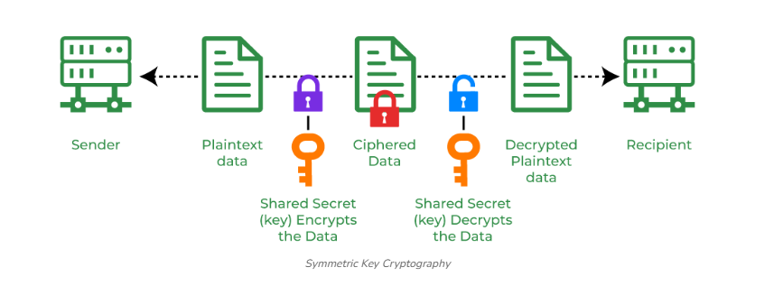
Data Encryption Standard (DES)
DES (Data encryption standard) is an older encryption algorithm that is used to convert 64-bit plaintext data into 48-bit encrypted ciphertext.
- It uses symmetric keys (which means same key for encryption and decryption).
- It is kind of old by today’s standard but can be used as a basic building block for learning newer encryption algorithms.

AES (Advanced Encryption Standard):
AESs a popular encryption algorithm which uses the same key for encryption and decryption.
- It is a symmetric block cipher algorithm with block size of 128 bits, 192 bits or 256 bits.
- AES algorithm is widely regarded as the replacement of DES (Data encryption standard) algorithm.
2. Hash Functions
Hash functions do not require a key. Instead, they use mathematical algorithms to convert messages of any arbitrary length into a fixed-length output, known as a hash value or digest.
SHA-1:
- It was designed to ensure data integrity by converting any input into a fixed-size 160-bit (20-byte) hash value.
MD5:
- MD5 produces a 128-bit hash value (32-character hexadecimal number) from input data of any size.
MD6:
- It was created to be highly secure and suitable for modern computing systems, including multi-core processors.
MD6-128
MD6-256
MD6-512
SHA-256
- The SHA-256 algorithm belongs to the family of the SHA 2 algorithms.
- It generates a fixed 256-bit (32-byte) hash value from input data of any length.

3. Asymmetric Key Cryptography
In Asymmetric Key Cryptography a pair of keys is used to encrypt and decrypt information. A sender's public key is used for encryption and a receiver's private key is used for decryption.
RSA (Rivest-Shamir-Adleman):
RSA is an basic asymmetric cryptographic algorithm which uses two different keys for encryption. The RSA algorithm works on a block cipher concept that converts plain text into cipher text and vice versa
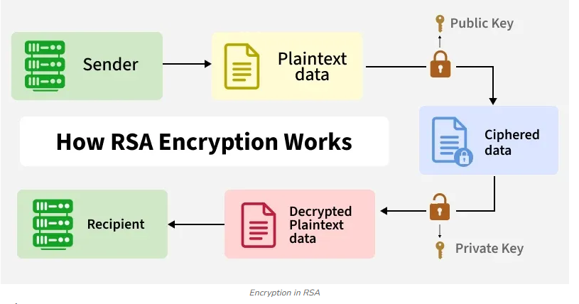

Encrypting large data?

Symmetric
Sharing keys securely? → Asymmetric
Storing passwords / checking integrity? → Hashing

SVN
Why earlier SVN was used and Now we transferred to Git

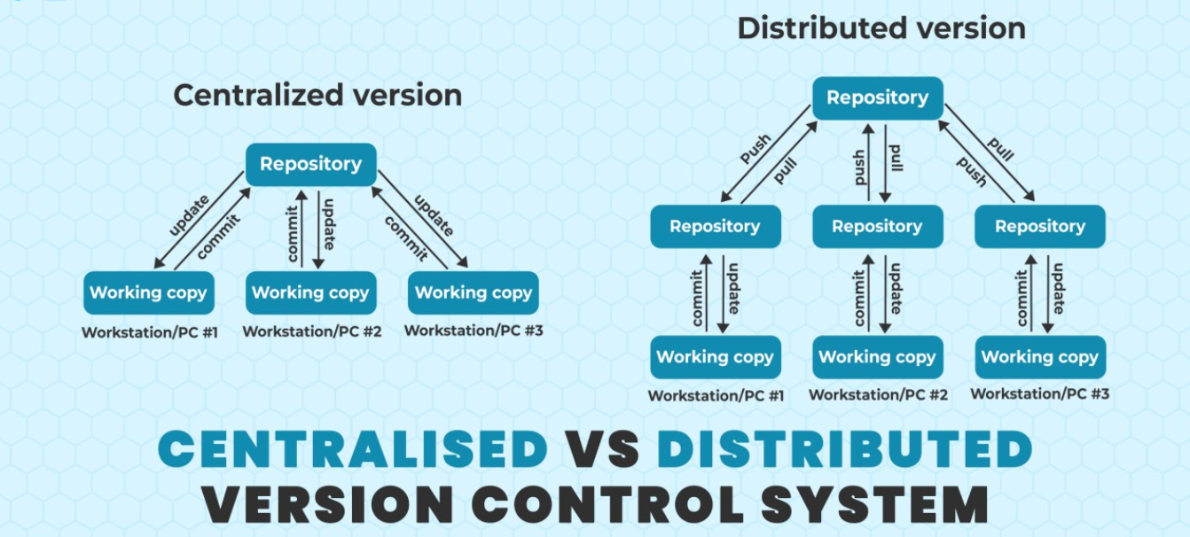

SVN (Subversion) is a centralized version control system (VCS) used to track changes to source code, documents, and project files.

Action | Meaning
svn checkout | Get a working copy of the repository
svn update | Pull the latest changes
svn commit | Push your changes to the central repo
svn branch / svn merge | Create and merge branches (often avoided due to complexity)

1. Checkout
Each developer downloads the project:
svn checkout http://example.com/svn/project
2. Developer A makes changes
- A edits login.js
- A tests locally
- A commits:
svn commit -m "Fix login validation"
3. Developer B makes changes at the same time
- B edits the same file without updating first
- B tries to commit → SVN rejects the commit:
Commit failed - out of date
4. Developer B updates
svn update
- If the same lines were edited → B must manually resolve conflicts
- After resolving:
svn commit -m "Add forgot password logic"
5. Developer C merges a branch
- Branching is heavy and slow in SVN
- C must manually merge changes and handle conflicts
- Merging large branches often becomes risky and painful
Limitations
- Centralized = single point of failure
- Merging is hard
SVN merging is slow, complicated, and error-prone:
- Branching discouraged → fewer feature branches
- Teams often committed directly to trunk → more breakage

- Slow performance
a network connection
History checks are server-dependent
- Limited offline work

Branching
SVN branches exist, but they behave very differently from Git branches, and merging in SVN has historically been:
- more manual
- more error-prone
- slower
- lacking true merge tracking
Command
svn merge ^/branches/feature-abc
svn resolve --accept=working file.txt
All merging work is done on your local machine, and SVN historically didn’t track merge metadata well.
- SVN: cannot rewrite history

SVN branching (directory-based)
Git branching (pointer-based)

Pipelines
